Bishop McLaughlin Catholic High School
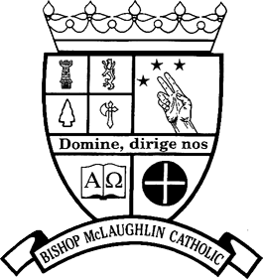
Est. 2003
13651 Hays Road
Spring Hill, Florida 34610

Pastoral Approval Form
2023-2024

Please complete in full and print legibly: (Please turn this form into your Parish Office.)

Parent(s): ____________________________________________________________________

Parish: _____________________________________________________________________

Parish Address: ______________________________________________________________

Parish City: _________________________________________ Parish Zip Code: _________

Name of Student: _____________________________________________________________

I do attend my home parish for weekly Mass and promise to continue to do so. I also promise, to the best of my ability, to be an active member of my home parish. (The home parish is the one in which you are registered.)

Student signature: ___________________ Parent/Guardian signature: ______________________

To be completed by the pastor of your home parish:

The above-named student is requesting admission to Bishop McLaughlin Catholic High School for the 2023-2024 school year. Please verify that his/her family is registered and are practicing members of your parish. Also verify that they are active, contributing members of the congregation and that you support the student attending Bishop McLaughlin Catholic High School.

Pastor’s Signature: ________________________________ Date: _________________________
Printed Name of Pastor: ____________________________

(PARISH SEAL)

This form needs to be returned no later than thirty days after the first day class is attended.
Late submissions will not be accepted for Parish Affiliated Rate.
________________________________________________________________________________
NON-AFFILIATED FAMILIES should complete the following section and return it to Bishop McLaughlin Catholic High School.

Please check: ____ our family is not affiliated with a Catholic Parish in the Diocese of St. Petersburg.

Parent signature: ____________________________________ Date: _______________

Please scan to admissions@bmchs.com or Attn: Admissions Department, Bishop McLaughlin Catholic High School,
13651 Hays Road, Spring Hill, FL 34610

